**Recommendation on the Placement of New Treatment Facilities**

Texas Department of Family and Protective Services

Samuel York

**Statement of Purpose**

In recent days, we have been given the opportunity to open a pair of new Residential Treatment Facilities (RTCs), by two contractors we have worked with in the past. These contractors are both willing to open their new facility at any location within the state, so long as they are serving the areas in most need. They defer to our judgement regarding which locations have the most need.

There are two primary factors which we think are important when it comes to assessing the need of an area: location and quality of care. In the former case, we generally think it is important to keep children near the location from which the originate such that they can maintain a sense of stability in their life and so that they may be more easily reunified with their family when appropriate. As such, we will attempt to recommend regions in which there is a particularly high rate of children being placed in a region different from their home, as this would indicate that there are not enough facilities in their home region to care for all of the children in that region.

In the latter case, it is the best practice when caring for a child to allow that child a substantial amount of individual, personalized, interaction with their caretaker. As such, we want to place these new facilities in counties where there are particularly high numbers of children per facility, to promote the individualized care our children need to excel. However, the number of children per facility alone doesn’t necessarily capture the needs of those children. It is well recognized within the department that some children need more attention than others, and that a facility with a fewer absolute number of children might actually need more assistance than a facility a larger absolute number of children, if those children are at a higher Authorized Level of Care (ALOC). Therefore, we will be considering both the number of children per facility and the level of care those children require into account when making our recommendation.

**Analysis**

In the first step of our recommendation, we wanted to identify the regions in which there seems to be a lack of service providers based on the number of children being placed in non-local facilities. In order to do this, we examined the percentage of children from each region whose placement region was different from their home (legal) region. The results indicate that the majority of children originating from regions four and nine (51% and 54% respectively) are being placed in regions outside of their home region. Most commonly these children are placed in adjacent regions, for example most children who left region four are placed in region three. Given this it is possible that the children are being placed in the nearest RTC, but that this facility just happens to be in a different region, and without more data (such as the county of origin) we cannot ignore this possibility. Beyond this, region six was the most common destination region scoring relatively highly even for non-adjacent regions. For example, region six was the second most common destination region for children originating in region four, after region three.

Second, we wanted to identify which counties might not be providing the most individualized care for their children, based on the number of children per facility in that county and the level of care required by those children. In order to do this, we calculated the average number of children per facility in each county, weighting the child by the level of care they require.[1] The results indicate that Harris county has the highest average number of children per facility (in both the weighted and unweighted analysis) followed by Caldwell county (which scores fourth in the unweighted analysis).

It should be noted that within this analysis we are assuming that RTCs are relatively homogenous in nature, or that they all are of comparable size and have comparable numbers of staff. Given that Harris county houses a relatively large city, it is possible that the facilities there are larger and better staffed, which would compensate for the relatively high number of children per facility. As such, a better analysis would account for the number of caretakers per child, rather than the number of children per facility. But, without this data, the number of children per facility is the best approximation for need.

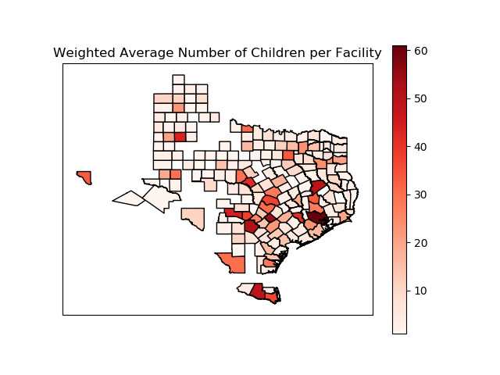

**Recommendation**

Given the analysis above we recommend placing the two new facilities in Harris and Smith counties. Harris county was chosen primarily based on its high average number of children which is only exacerbated by the fact that it is a common destination region. Placing one of the facilities here should provide some immediate relief. Smith county was chosen based on the fact that region four has a high rate of placing children in a different region than they originate from, with the placement region often being non-adjacent (region six in particular). Placing a facility here will help keep children near their home. This choice will likely also help with the high numbers of children per facility in Harris, as region six is the second most common placement region for those leaving region four.

Midland county was also considered as a second choice, as it also has a high rate of placing children in regions separate from the region they originate from. However, region nine generally places children in adjacent regions (i.e. two and seven), and given the size of the region, it seems possible they are placing children in the closest facility, but that facility just happens to be in a different region. To put it in words, Mason is closer to Llano than Midland even if they are in different regions, but Anderson is both far from Harris and in a different region. As such, a new center in Smith seems more appropriate than a new center in Midland.

1. Determining the weight which we should assign different children is somewhat of a tricky business. Does a child that requires a specialized amount of care (ALOC 230) need twice as much attention as children as one that only requires basic care (ALOC 210)? More or less? To make a full recommendation we should conduct a study, and discuss with the service providers themselves, regarding how much more attention children from each level of care require above and beyond the basic care. Lacking that information, I decided to assign a relatively conservative weight, saying that each additional level of care over basic required 15% more attention than the level below it. In other words, within the calculation children at ALOC 210 were counted as one child, children at ALOC 220 were counted as 1.15 children, children at ALOC 230 were counted as 1.32 children, and so on.